<dd/mmm/yyyy>
<Name of PI>
Principal Investigator
Peregrine Eye and Laser Institute
50 Jupiter St., Bel-air Makati City
Re: <Protocol Title><PELI-IRB Code>
Dear <Name of PI>:
We wish to inform you that the Peregrine Eye and Laser Institute-Institutional Review Board (PELI-IRB) acknowledged receipt of <Post-approval document> received last <date received>.
Upon review of <Submitted Document>, the IRB action is REQUEST INFORMATION. Recommended revisions and/or clarifications are summarized below:
Please note that the cut-off date for submission is on <Insert deadline>. Should you have any questions or clarifications regarding the abovementioned recommendations, please contact the undersigned at (02) 511-8506 or irb@peregrineeye.com.
The PELI-IRB looks forward to your immediate response and action.
Very truly yours, 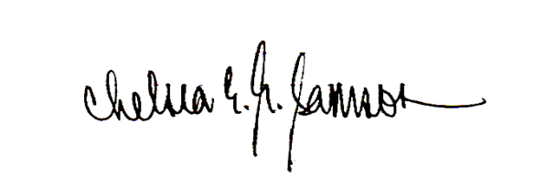
CHELSEA ELIZABETH SAMSON, MD-MBA
Chair, PELI-IRB

